Technical Architecture
Architecture Overview

EduGenie is a lightweight AI-powered educational assistant with a simple HTML + CSS frontend and a FastAPI backend. The application provides five major learning functionalities:
Question & Answer
Concept Explanation
Quiz Generation
Text Summarization
Personalized Learning Recommendations

The backend connects these modules with two AI models:
Google Gemini 1.5 Pro — used for Q&A, summarization, quiz generation and learning paths.
LaMini-Flan-T5-783M — used locally for simplified concept explanations. EduGenie-Google Gemini Powered Learning Assistant_Document.pdf
Architecture Flow
User → HTML/CSS Web Interface → FastAPI Backend → Application Modules → AI Models → Response → Web Interface\

More specifically:

User Input
↓
HTML + CSS Frontend
↓
FastAPI REST API
↓
Task Selection
/qa
/explain
/quiz
/summarize
/learn/recommendations
↓
Corresponding Application Module
↓
Gemini 1.5 Pro / LaMini-Flan-T5-783M
↓
Generated Result
↓
Frontend Display
The project document confirms that each FastAPI endpoint is connected to its respective module logic.

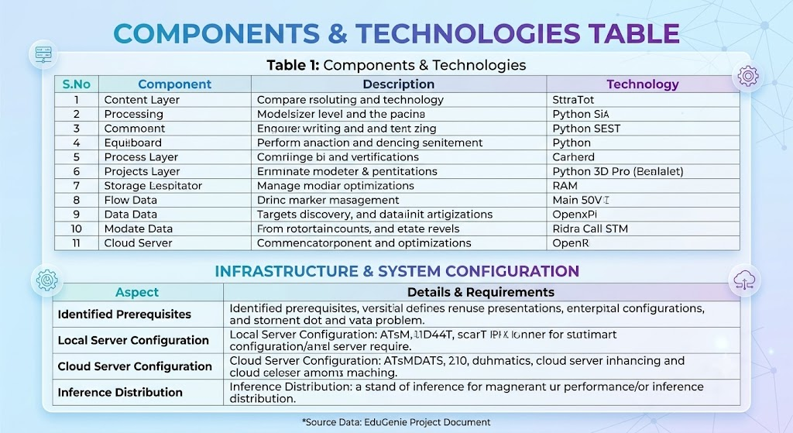
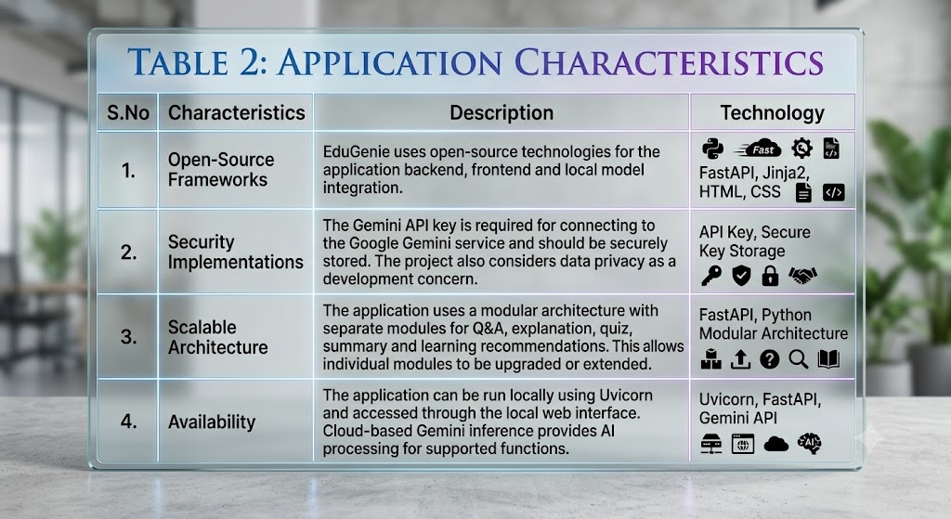

Performance

EduGenie uses a lightweight local model for concept explanation and cloud-based Gemini inference for advanced generative tasks. The lightweight infrastructure is designed to work efficiently even on devices such as Mac M1.
LaMini-Flan-T5-783M, Gemini 1.5 Pro, FastAPI
The project specifically describes the infrastructure as lightweight and notes its ability to work on devices such as Mac M1. EduGenie-Google Gemini Powered Learning Assistant_Document.pdf
Technology Stack Summary
Frontend: HTML, CSS, Jinja2
Backend: Python, FastAPI
Server: Uvicorn
Cloud AI: Google Gemini 1.5 Pro / Gemini API
Local AI: LaMini-Flan-T5-783M
Architecture: Modular REST API
Storage: Local file system
Deployment: Local execution with Uvicorn
API Endpoints: /qa, /explain, /quiz, /summarize, /learn/recommendations

Architecture Diagram Content

For the diagram in your template, you can draw these blocks:

┌──────────────────────┐
│ USER │
└──────────┬───────────┘
│
▼
┌──────────────────────┐
│ HTML + CSS Frontend │
│ Jinja2 │
└──────────┬───────────┘
│
HTTP POST
│
▼
┌──────────────────────┐
│ FastAPI Backend │
│ Uvicorn │
└──────────┬───────────┘
│
┌────────────────┼────────────────┐
│ │ │
▼ ▼ ▼
┌─────────┐ ┌──────────┐ ┌──────────┐
│ Q&A │ │ Explain │ │ Quiz │
│ Module │ │ Module │ │ Module │
└────┬────┘ └────┬─────┘ └────┬─────┘
│ │ │
▼ ▼ ▼
┌────────────┐ ┌────────────────┐ ┌──────────────┐
│ Gemini │ │ LaMini-Flan- │ │ Gemini 1.5 │
│ 1.5 Pro │ │ T5-783M │ │ Pro │
└────────────┘ └────────────────┘ └──────────────┘
│ │ │
└────────────────┼────────────────┘
▼
┌──────────────────────┐
│ Summary & Learning │
│ Path Modules │
└──────────┬───────────┘
│
▼
┌──────────────────────┐
│ Result to User │
└──────────────────────┘

This architecture follows the actual modules and technologies documented in your project rather than adding unrelated technologies.

